Google Cloud Build SAST
Integrate AccuKnox SAST scanning into Google Cloud Build to catch source code vulnerabilities before they ship. The pipeline uses the AccuKnox ASPM Scanner CLI with Opengrep, runs in three steps, and uploads findings directly to your AccuKnox CSPM panel.

Prerequisites
• GCP project with Cloud Build enabled
• AccuKnox SaaS access with permission to generate tokens
• A GitHub, GitLab, Bitbucket, or Cloud Source Repository connected to Cloud Build
• A Cloud Build trigger pointing at the repository you want to scan

Steps for integration

Step 1: Generate an AccuKnox token
Log in to AccuKnox SaaS. Navigate to Settings, then Tokens and create a new token.
#Screenshot
Save these three values for use in Step 3:
Field | Where to find it
Endpoint | Your AccuKnox CSPM URL, for e.g, cspm.demo.accuknox.com
Token | The token string shown after creation
Label | Any descriptive string you choose,

Step 2: Add the cloudbuild.yaml to your repository
Drop the following file at the root of your repository as cloudbuild.yaml.
# =============================================================================
# AccuKnox SAST (Opengrep) - Google Cloud Build Pipeline
# Scans the repo with Opengrep and uploads results to the AccuKnox CSPM panel.
# =============================================================================
steps:
# Step 1: Validate required inputs (fail fast)
- id: validate-inputs
name: ubuntu:24.04
entrypoint: bash
env:
- ACCUKNOX_ENDPOINT=${_ACCUKNOX_ENDPOINT}
- ACCUKNOX_TOKEN=${_ACCUKNOX_TOKEN}
- ACCUKNOX_LABEL=${_ACCUKNOX_LABEL}
args:
- -c
- |
set -e
if [ -z "$$ACCUKNOX_ENDPOINT" ] || [ -z "$$ACCUKNOX_TOKEN" ] || [ -z "$$ACCUKNOX_LABEL" ]; then
echo "ERROR: _ACCUKNOX_ENDPOINT, _ACCUKNOX_TOKEN, and _ACCUKNOX_LABEL must be set!"
exit 1
fi
echo "All required inputs present."
# Step 2: Download the AccuKnox ASPM Scanner CLI
- id: download-scanner
name: ubuntu:24.04
entrypoint: bash
args:
- -c
- |
set -e
export DEBIAN_FRONTEND=noninteractive
apt-get update -qq
apt-get install -y -qq --no-install-recommends curl ca-certificates
curl -sSL https://github.com/accuknox/aspm-scanner-cli/releases/download/v0.14.2/accuknox-aspm-scanner \
-o /workspace/accuknox-aspm-scanner
chmod +x /workspace/accuknox-aspm-scanner
# Step 3: Install Opengrep, run the SAST scan, upload to AccuKnox CSPM
- id: run-sast-scan
name: ubuntu:24.04
entrypoint: bash
env:
- SOFT_FAIL=${_SOFT_FAIL}
- PIPELINE_ID=${BUILD_ID}
- JOB_URL=https://console.cloud.google.com/cloud-build/builds/${BUILD_ID}?project=${PROJECT_ID}
- ACCUKNOX_ENDPOINT=${_ACCUKNOX_ENDPOINT}
- ACCUKNOX_TOKEN=${_ACCUKNOX_TOKEN}
- ACCUKNOX_LABEL=${_ACCUKNOX_LABEL}
- REPO_URL=${_REPO_URL}
- COMMIT_SHA=${COMMIT_SHA}
args:
- -c
- |
set -e
export DEBIAN_FRONTEND=noninteractive
apt-get update -qq
apt-get install -y -qq --no-install-recommends ca-certificates
/workspace/accuknox-aspm-scanner tool install --type sast
SOFT_FAIL=$(echo "$$SOFT_FAIL" | tr -d ' \t\r\n')
SOFT_FAIL_ARG=""
if [ "$$SOFT_FAIL" = "true" ]; then
SOFT_FAIL_ARG="--softfail"
fi
if [ -z "$$COMMIT_SHA" ]; then
COMMIT_SHA="manual-$$PIPELINE_ID"
fi
/workspace/accuknox-aspm-scanner scan --keep-results $$SOFT_FAIL_ARG sast \
--command "." \
--repo-url "$$REPO_URL" \
--commit-sha "$$COMMIT_SHA" \
--pipeline-id "$$PIPELINE_ID" \
--job-url "$$JOB_URL"
substitutions:
_ACCUKNOX_ENDPOINT: ""
_ACCUKNOX_TOKEN: ""
_ACCUKNOX_LABEL: ""
_SOFT_FAIL: "true"
_REPO_URL: ""
options:
logging: CLOUD_LOGGING_ONLY
machineType: E2_HIGHCPU_8
timeout: 1800s

Commit and push the file to your repository.

Step 3: Configure the Cloud Build trigger
Open Cloud Build in the GCP console. Create or edit a trigger pointing at your repository.
Under Configuration, select Cloud Build configuration file and point it at cloudbuild.yaml.
Under Advanced, then Substitution variables, add:
Variable name | Value
_ACCUKNOX_ENDPOINT | Your CSPM endpoint, for example, cspm.demo.accuknox.com
_ACCUKNOX_TOKEN | The token from Step 1
_ACCUKNOX_LABEL | A label of your choice, for example, sast-myapp
_REPO_URL | Your repo URL, for example, https://github.com/your-org/your-repo.git
_SOFT_FAIL | optional. true (default) or false to fail the build on findings

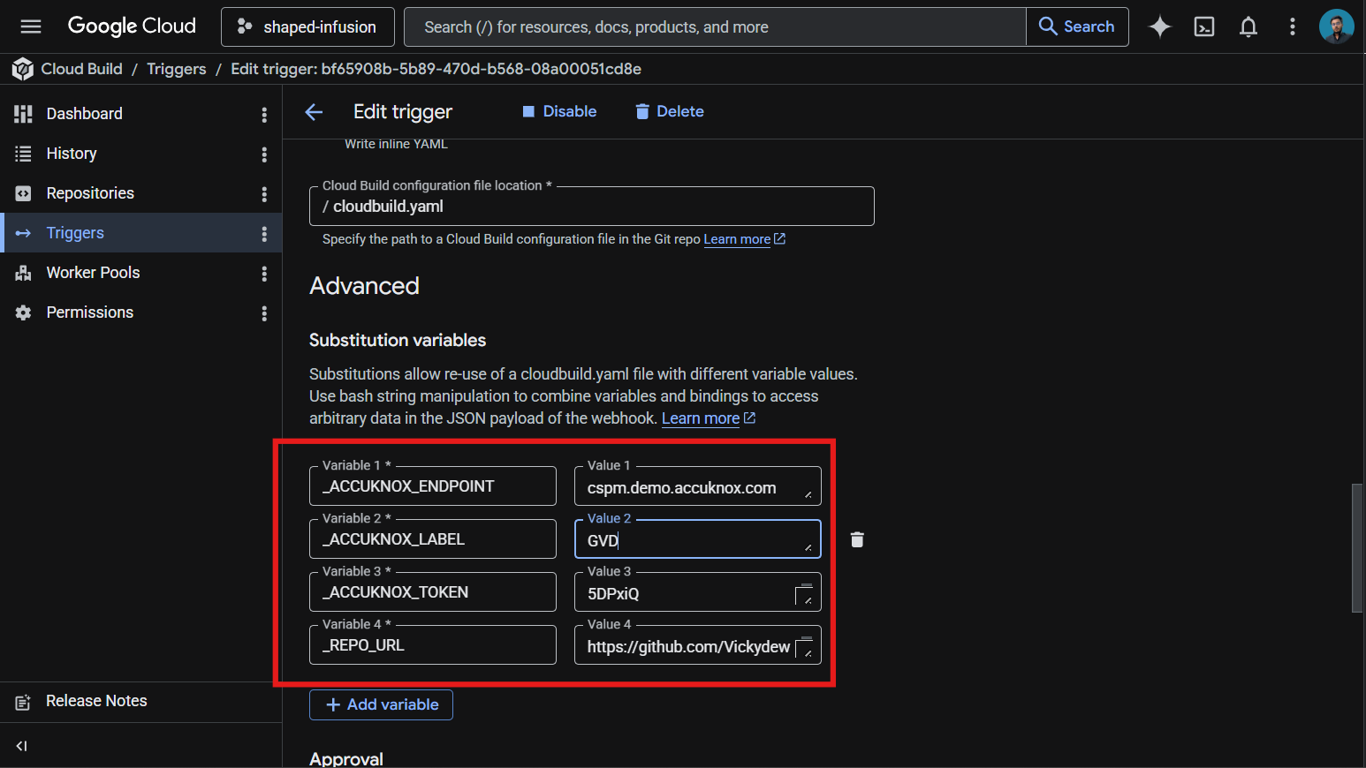
These values live in the trigger config rather than the YAML, which keeps your token out of git history.
Save the trigger. The next push to the watched branch runs the pipeline.

How the pipeline works
Step | Purpose
1. validate-inputs | Fails the build in under a second if any required substitution is empty. Saves a wasted scanner download when the token is missing.
2. download-scanner | Fetches the AccuKnox ASPM Scanner v0.14.2 binary into /workspace, which persists across Cloud Build steps.
3. run-sast-scan | Installs Opengrep locally via the scanner CLI, runs the scan against the repo root, and uploads findings to AccuKnox CSPM.

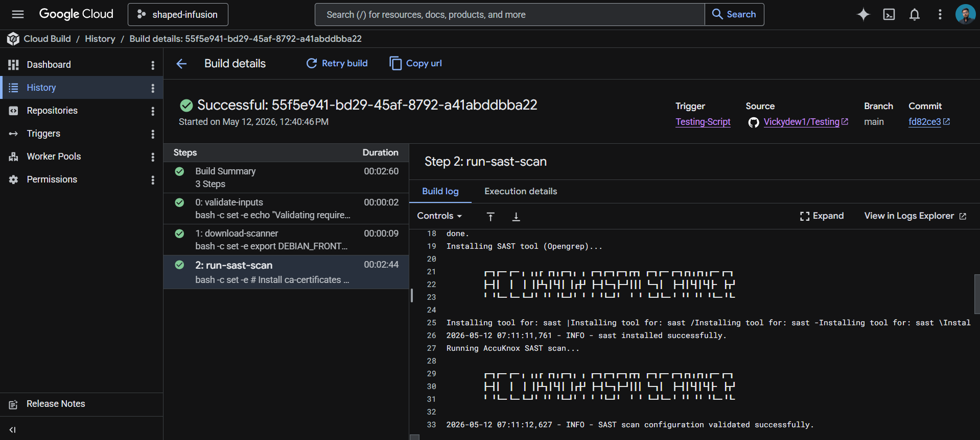

Viewing results
Open the AccuKnox CSPM panel. Filter findings by the label you set in _ACCUKNOX_LABEL. Each finding includes the file, line number, rule ID, and severity, with a direct link back to the offending Cloud Build run.

Before the AccuKnox scan
Without SAST integration, source code vulnerabilities such as SQL injection, hardcoded credentials, or insecure deserialization slip through every push. The CI/CD pipeline builds and deploys the artifact whether the code is safe or not.

After AccuKnox scan integration
Once the pipeline above is wired up, every push triggers the SAST scan. Opengrep flags issues like SQL injection patterns, weak crypto, or unsafe input handling within minutes. Findings appear in your AccuKnox CSPM panel with severity, file location, and remediation guidance. Critical issues can fail the build by toggling _SOFT_FAIL to false.


